MISR UNIVERSITY FOR SCIENCE & TECHNOLOGY

FACULTY OF ENGINEERING MECHATRONICS DEPARTMENT

**Proposal for (ADAS) Graduation Project**

Submitted by.

|  |  |
| --- | --- |
| Name | ID |
| Abanob Malak | 95689 |
| Kareem Ahmed | 95635 |
| Omar Mohamed | 95668 |
| Magdy Maged | 91672 |
| Essam Alaa | 91679 |

Supervised by

Dr. Bahaa Eldin Mohamed

Contents

Abstract 1

Introduction 1

Literature Review 2

(Mechanical) 2

Ackerman Chassis: 2

(Electrical) 3

Project Objective: 3

Features: 4

1) Blind Spot Detection (BSD): 4

2) Adaptive Cruise Control (ACC): 5

3)Traffic Sign Recognition (TSR): 7

Proposed Solution 8

Expected Outcomes 8

Conclusion 9

Expected Cost 10

# Abstract

This project develops an Advanced Driver Assistance System (ADAS) to improve road safety and driving comfort through four integrated features: Traffic Sign Recognition, Adaptive Cruise Control, Bump Detection, and Blind Spot Detection. Traffic Sign Recognition uses computer vision to alert drivers to key information. Adaptive Cruise Control adjusts vehicle speed to maintain a safe distance. Blind Spot Detection monitors unseen areas, alerting drivers to nearby vehicles. Together, these features enhance safety, reduce accidents, and improve driving efficiency.

**Our Project is specifically handling the following systems:**

* **Traffic sign Recognition**
* **Adaptive Cruise Control**
* **Blind Spot Detection**

# Introduction

A driver is one of the “best sensors in the vehicle” and is primarily responsible for avoiding crashes. However, a large proportion of crashes are still attributed to driver errors. A survey was conducted to identify the critical reason for each crash, and the “National Sample of U.S. Crashes” from 2005 to 2007 was examined. It was noted that driver error was the critical factor contributing to 94% of crashes, as shown in Fig.

Figure 1

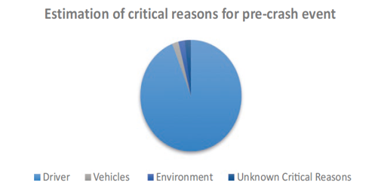

These errors include recognition errors, decision errors, performance errors, and non-performance errors. Recognition errors result from driver inattention and inadequate surveillance; decision errors arise from misjudgments; performance errors stem from overcompensation, poor directional control, etc.; and non-performance errors occur due to sleeping and fatigue.

The development and deployment of new in-vehicle technologies to counteract these driver errors, and thus support the driver in preventing crashes, is ongoing. Advanced Driver Assistance Systems (ADAS) are a group of vehicle technologies that provide timely warnings to drivers about risky or hazardous situations to help avoid crashes. Some ADAS technologies actively and automatically intervene to prevent hazardous situations or when the system detects that a crash is imminent. ADAS technologies are the precursor to autonomous vehicles and, depending on the combination of ADAS equipment installed in a vehicle, can currently enable level 1 to level 2 autonomous driving, as represented in Fig. A close-up of a diagram

Figure 2

# Literature Review

## (Mechanical)

### Ackerman Chassis:

The robot is built with an Ackerman chassis structure, allowing it to be driven by the rear wheel while being controlled by the front wheel. The front wheel steering mechanism resembles that of a real car, enabling basic driving functions such as forward movement, reverse, and wide-radius steering. However, it does not support in-place steering. The Ackerman chassis offers not only excellent steering capabilities but also a certain degree of climbing ability.

**Preface**

Ackermann's steering structure was initially proposed by a German carriage engineer in 1817. Later, his agent Ackermann applied for a patent in 1818, and as a result, the steering principle came to be known as Ackermann's steering geometry. The primary purpose of this design was to enhance the steering mechanism for carriages, as depicted in the figure below: The limitations of such a structure are evident and include the following: Turning around a single axis during vehicle turns results in limited space for turning, preventing the wheels from being made into a larger size. Consequently, encountering gravel or obstacles on the road can easily lift the vehicle. The parallel steering of the two front wheels in this design can cause the four wheels to form a "triangle" when turning with a large steering angle. This situation can lead to the vehicle getting stuck in one position and becoming immovable.

**Ackermann Chassis Structure**

JetAcker utilizes the Ackermann chassis design. To achieve stable turning, it is

essential to ensure that the two front wheels rotate around the same circle

origin. Consequently, the rotation angle of the two front wheels may vary.

These front wheels can be categorized as the outside wheel and the inside

wheel. The diagram below illustrates the turning mechanism of the Ackermann

The driving mechanism consists of servos, links, and wheels. The servos are

connected to the links, and these links, in turn, are connected to the wheels.

By rotating the servos, the movement of the links is controlled, thereby

determining the turning direction of the front wheels. The working principle of

this mechanism is as follows:

## (Electrical)

### Project Objective:

ADAS can work an important role in many factors to reduce the number of crashes cases as possible using the power of sensors and Machine learning algorithms to analyze the environment around the vehicle and take the required action in the suitable time

**These factors are:**

* **Traffic sign Recognition**
* **Adaptive Cruise Control**
* **Blind Spot Detection**

# Features:

## Blind Spot Detection (BSD):

Installed on the side mirrors or rear bumper, blind spot sensors identify vehicles or objects in the car's blind spots. The system alerts the driver to be cautious when changing lanes or making maneuvers and may prompt corrective action if necessary, reducing the likelihood of collisions.

**Development Stages:**

The Blind Spot Detection System involves several key stages, including system architecture design, sensor setup and testing, hardware integration, software development, and comprehensive testing to ensure functionality and reliability.

**Design Components:**

* **Sensors**: BSD systems utilize various sensors to monitor the areas around the vehicle. These can include radar, ultrasonic sensors, or cameras. Radar sensors use radio waves to detect objects, ultrasonic sensors emit sound waves, and cameras capture visual information. Each sensor type has its strengths: radar is ideal for low-visibility conditions, ultrasonic sensors are useful for close-range detection, and cameras provide detailed visual data.

Figure 3

* **Data Processing Unit**: This unit processes the data received from the sensors, using advanced algorithms to analyze signals or images and determine the presence and position of objects in the blind spots.
* **Alert Generation System**: Once an object is detected, the system generates alerts to notify the driver. Alerts can be visual, such as icons or indicators on the side mirrors or dashboard, or auditory, like beeps or spoken messages.

**Working Process:**

1. **Sensor Monitoring**:  
   The BSD system continuously monitors the vehicle’s blind spot areas using strategically placed sensors. These sensors provide real-time information about objects or vehicles present in these zones.
2. **Object Detection**:  
   The sensors detect objects within the blind spot areas by emitting signals (radio waves, sound waves, or capturing visual data) and analyzing the returning signals or images. The data processing unit analyzes this information to identify and classify objects.
3. **Object Position Determination**:  
   The system determines the position, speed, and trajectory of detected objects relative to the vehicle’s position and movement. This helps assess the risk of a potential collision.
4. **Alert Generation**:  
   If an object in the blind spot poses a potential risk, the system triggers alerts to notify the driver. These alerts can be:
   * **Visual Alerts**: Displayed on the side mirrors, dashboard, or heads-up display, using icons or symbols to indicate the presence of an object or vehicle.
   * **Auditory Alerts**: Beeps or spoken messages to draw the driver’s attention to the presence of an object or vehicle in the blind spot.
5. **Driver Response**:  
   Upon receiving an alert, the driver can take appropriate action, such as delaying a lane change, adjusting speed, or checking the blind spot and mirrors more carefully before proceeding. These alerts improve driver awareness and decision-making, reducing the likelihood of blind spot-related accidents.

## 2) Adaptive Cruise Control (ACC):

ACC employs a **depth camera** and **LiDAR** to monitor the distance between the car and preceding vehicles. By autonomously adjusting the car's speed and following distance, ACC ensures a safe and consistent driving experience, particularly in congested traffic conditions.

Scientific Methodologies and Theories for ACC:

* **Adaptive Cruise Control System**: AI Model and Algorithm Research, Component Acquisition, System Architecture Design, setting up Jetson Nano and Camera, AI Model Development.
* **Working of Adaptive Cruise Control**:
  + the radar or LiDAR sensor transmits signals at a given frequency toward an incoming car.
  + The reflected signals return at a different frequency, depending on the relative speed of the car being tracked.
  + A processing device compares the transmitted frequency to the received frequency to determine the speed and distance of the car in front.
  + The ACC system is programmed to maintain a safe following distance by adjusting the vehicle's speed, based on the input from sensors.
  + The system gives output to the braking and acceleration units if the distance between the car and the object in front is less than the predefined safe distance value, thereby ensuring the distance is always maintained.

**Sensors:**

A **sensor** is a device that measures a physical quantity and converts it into a signal that can be interpreted by a human observer or an instrument. Sensors respond to an input quantity by generating a functionally related output, usually in the form of electrical or optical signals. In this project, two types of sensors are used:

* **LiDAR**: Light Detection and Ranging (LiDAR) is a ranging device that measures the distance to a target by emitting laser pulses and analyzing the reflected light. The distance is determined by measuring the time difference between the emitted pulse and the reflected pulse.
* **Fusion Sensor (Camera)**: A camera is used in conjunction with LiDAR to detect and classify objects. The fusion of these sensors allows for distinguishing between moving and stationary objects, providing more accurate data for ACC.

These two sensors work together to ensure the car can safely follow other vehicles while detecting and avoiding obstacles, both moving and stationary.

**TF-Luna:**

The **TF-Luna** is a single-point ranging LiDAR sensor based on the Time of Flight (TOF) principle. Using an 850nm infrared light source, it provides stable, accurate, and highly sensitive distance measurements. The TF-Luna sensor includes built-in adaptation algorithms for various environments and targets. It supports customizable configurations to ensure excellent performance in complex scenarios, such as changing weather or lighting conditions.

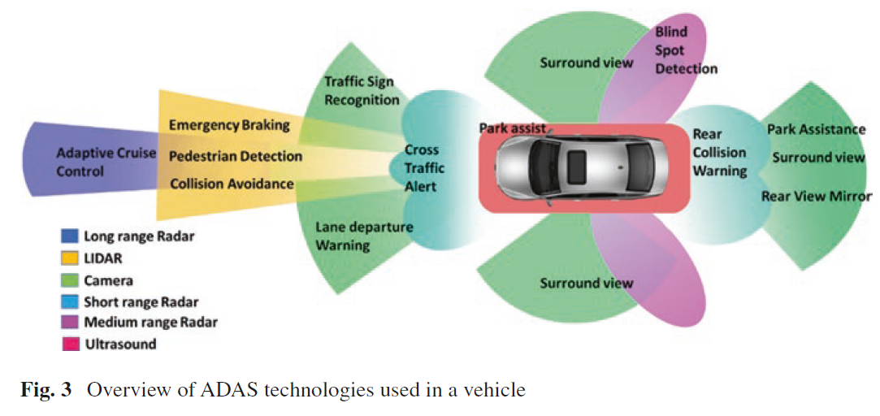

Figure 4

## 3)Traffic Sign Recognition (TSR):

Using a camera module and advanced image processing algorithms, the Traffic Sign Recognition (TSR) system detects and interprets various traffic signs, including speed limits, stop signs, and directional indicators. It provides the driver with relevant information to enhance situational awareness and ensure adherence to traffic regulations.

### Scientific Methodologies and Theories for TSR:

Traffic Sign Recognition System: We will review existing literature on traffic sign recognition to inform our approach. Our methodology includes selecting and acquiring relevant datasets (such as the Egypt and German datasets), splitting the data into training and validation sets, training the AI model using this data, and evaluating its performance with real-world scenarios.

**Importance of AI and Model Selection:**

Selecting the right AI model is crucial for traffic sign recognition, as it must meet specific performance criteria. Different models offer varying strengths, including real-time processing capabilities, accuracy, adaptability to different conditions, and efficiency on devices with limited resources.

AI models play a key role in interpreting visual data from road signs by utilizing advanced deep learning architectures. These models enable vehicles to analyze images or video frames effectively, allowing them to respond appropriately to dynamic road conditions.

The choice of AI model depends on several factors:

* Real-Time Processing: Ensures timely detection and classification of traffic signs.
* Accuracy: Guarantees precise recognition to enhance safety and compliance.
* Efficiency: Optimizes performance on devices with constrained computational resources.
* Adaptability: Handles diverse environmental conditions, such as varying lighting and weather.

### Considerations for Model Selection:

* + Real-time Processing: Models like YOLO and SSD are ideal for applications that require real-time detection and classification of traffic signs.
* Accuracy and Precision: Accurate recognition and classification of traffic signs are crucial for the safe operation of the system.
* Adaptability: The AI model must be adaptable to different environmental conditions, such as varying lighting, weather, and road scenarios.
* Resource Efficiency: Efficient models are necessary for use in edge devices or vehicles with limited computational power.

Balancing Real-time Performance and Accuracy:

Achieving a balance between real-time performance and accuracy is crucial for applications such as autonomous vehicles. Models must process data swiftly while maintaining high accuracy to ensure safe and reliable operation in intelligent transportation systems.

### Key AI Models:

Several AI models have proven effective in traffic sign recognition. Real-time object detection models, such as YOLO and SSD, have significantly advanced the capabilities of TSR systems, providing a solid foundation for developing reliable, high-performance solutions.

# Proposed Solution

The proposed solution involves the integration of various Advanced Driver Assistance Systems (ADAS) to enhance vehicle safety and driver experience. The primary objective is to develop a comprehensive system that incorporates the following technologies:  
  
**1- Road Sign Interpretation:**  
 - The integration of image recognition technology to identify and interpret traffic signs. This system will display relevant traffic information on the vehicle's dashboard, ensuring that the driver is always informed about speed limits, no-entry zones, and other critical road signs.

**2- Blind Spot Detection:**  
 - Deployment of sensors and cameras to monitor areas around the vehicle that are typically difficult for the driver to see. The system will provide visual or auditory warnings when another vehicle is detected in the blind spot, helping to avoid collisions during lane changes.

**3- Adaptive Cruise Control:**  
 - Developing a system that automatically adjusts the vehicle’s speed to maintain a safe distance from the vehicle ahead. This feature not only enhances driving comfort but also contributes to overall road safety by reducing the likelihood of rear-end collisions.

# Expected Outcomes

1. Providing the graduate student with an opportunity to apply what they have learned and implement it in their specific field of specialization.

2. Allowing the student to practice and apply professional ethics and work within a team before entering the workforce.

3. Offering the opportunity to invest in and find a sponsor for the project idea, facilitating its implementation in practical applications.

4. Preparing the graduate student to be an effective contributor in all scientific and research fields.

5. Ensuring that the graduate student can utilize their practical abilities, cognitive structures, and skills in writing, research, and documentation during their studies.

# Conclusion

In conclusion, advanced driver assistance systems (ADAS) have significantly contributed to enhancing vehicle safety and improving overall driving experiences. The integration of blind-spot detection systems has effectively reduced the occurrence of accidents caused by lane changes, particularly in scenarios where drivers have limited visibility. Traffic sign recognition systems have played a crucial role in improving compliance with traffic regulations. By accurately identifying and displaying relevant traffic signs, these systems help drivers stay informed and make better decisions while on the road.

Overall, advancements in ADAS technologies have demonstrated their effectiveness in preventing accidents, reducing human error, and enhancing overall road safety. As these systems continue to evolve, they have the potential to significantly reduce the number of collisions and make driving experiences safer and more enjoyable for everyone on the road.

# Expected Cost

